Unit Seven Project Menu

1. Create picture flashcards for some very important Holocaust figures and locations. Your cards will include a photo or drawing of the person/place and important statistics and facts about their role in the Holocaust. See instructions for further details. | 2. Write a letter from a prisoner in a concentration camp. Imagine that you are writing from a concentration camp describing your life, location, and experiences as a prisoner. See instructions for further details. | 3. Pretend that you are a news reporter who is given the task of revealing the truth about the Holocaust to the public. Write an article to inform readers about some aspect of the Holocaust that’s been revealed since the end of the war. Be descriptive and make sure your reader knows all the details. See instructions for further details.
4. Design a memorial to honor a Holocaust historical figure or event. You will illustrate your memorial, create the plaque that explains your memorial to visitors, explain your memorials location and construction, and more. See instructions for further details. |  | 5. Create a timeline of ten significant events of Holocaust. Your timeline should include the dates of each event and captions that explain their significance. See instructions for further details.
7. Become an expert on a topic related to Holocaust and prepare a 5-minute lesson that you can teach your classmates. You will give a brief report to your teacher and share what you know with the class. See instructions for further details. | 8. Create a Holocaust alphabet book in which you use the letters of the alphabet and illustrations to give information about important places, people, and events. See instructions for further details. | 9. Write a poem that explores facts and emotions related to Holocaust. You may choose between several types of poems and will include both facts and emotions in your poem. See instructions for further details.
Must Do: # _4_ + Choose _1__ more = Total Items: __2__ Due: Monday/Tuesday, April 18 and 19th

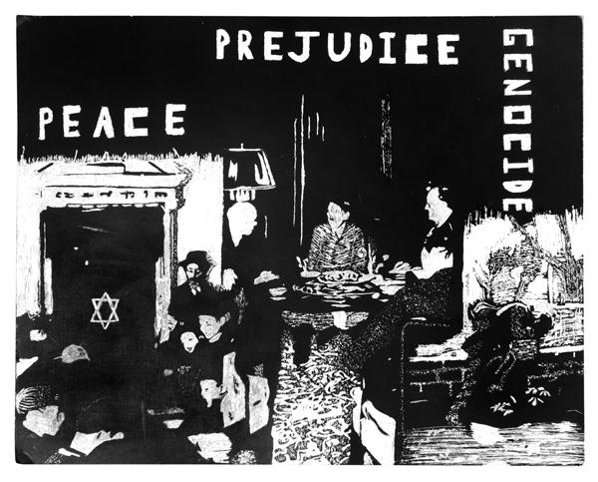

Make each project fact-based and accurate through any additional research. Please choose your sources wisely, and take your time reading through information carefully. Feel free to be creative, and make sure that your projects are based on accurate information from reliable sources.

- Create flashcards for some very important Holocaust figures and places. Your cards will include a photo/drawing of the person/place and important statistics and facts about their role in the Holocaust.
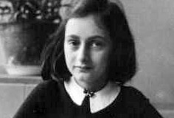
  - Create a “trading card” for each of the following people and places:
    - Adolf Hitler, Anne Frank, Germany, Nazi Party, Poland, concentration camp, Auschwitz, and 3 more of your choice (10 total)
  - Each card should contain:
    - A photo or drawing of the person/place
    - A short summary of their role in the Holocaust and at least 5 facts about the person/place
    - Their birth and death dates (if this applies)

- Write a letter from a prisoner in a concentration camp. Imagine that you are a prisoner writing a friend or relative outside the camp. Describe your location, why you’ve been placed in a camp, and life and experiences as a prisoner so far.(This should be around 200 words.)

- Your letter should include a proper date, heading, body, and closing
- You must include details about your location, why you’ve been placed in a camp, what life in a concentration camp is like, what you’ve witnessed, several experiences that you “remember,” and your feelings about Hitler and his concentration camps.

- Pretend that you are a news reporter who is given the task of revealing the truth about the Holocaust to the public. Write an article to inform readers about some aspect of the Holocaust that’s been revealed since the end of the war. Be descriptive and make sure your reader knows all the details. Remember, many people had no idea what was truly happening to Jews who were removed from their homes or forced to be imprisoned. “Expose” the truth behind the deportations and ghettos. Be descriptive and make sure your reader knows all the details.

- Your article should be at least 200 words long and nearly error FREE! (In other words, proofread and use spell check) It should tell key facts about the person or event and answer the following questions:
  - WHO is involved? WHAT is going on? WHERE is it going on? WHEN is this happening? WHAT are the causes for this news? You can even “interview” somehow directly involved with the Holocaust. Your facts should be based on research that you conduct about the Holocaust and the people and places involved.
  - Include at least one photo or drawing with your article

4. Design a memorial to honor a Holocaust historical figure or event. You will illustrate your memorial on a poster or sheet of paper, and create either a plaque that explains your memorial to visitors OR attach a separate sheet of paper to explain those details and your memorial’s location and construction. Your illustration should be detailed, realistic, and colored. Consider: who or what the memorial honors, what materials you would use to construct the memorial, where the memorial would be located, and what visitors could expect to see or experience when visiting the memorial. Research other examples of war memorials for ideas and inspiration.

5. Create a timeline of the ten most significant events of Holocaust. Your timeline should include the dates of each event and captions that explain their significance.

- Use your book, the internet, your notes, and other books to identify ten important events.
- You may use a material that you select for your timeline, but you may NOT use a sheet of notebook paper. (Ideas: sentence strips, poster, butcher paper, construction paper)
- Each event must contain the DATE and a BRIEF EXPLANATION OF THE EVENT
(EX: September 5, 1914- The First Battle of the Marne begins.)
- Include illustrations or photos for at least three events.

6. Become an expert on a topic related to Holocaust and prepare a 5-minute lesson that you can teach your classmates. You will give a brief report to your teacher and share what you know with the class.

- Select a topic to “teach” your classmates about, and have it approved by your teacher.
- Prepare a five-minute lesson about your topic that includes at least one visual aid (poster, pictures, PowerPoint, etc.)
- Be prepared to turn in notes or a brief report to your teacher to demonstrate your preparation for your “lesson”.
- You must be prepared to answer questions from your classmates about your topic!
- Topic ideas: a specific concentration camp, a specific Holocaust victim or survivor, military leader during this time

7. Create a Holocaust alphabet book in which you use the letters of the alphabet and illustrations to give information about important battles, people, and events of the war.

- You must have a page for EVERY letter of the alphabet (even Z).
- Your pages must have a word or sentence that begins with that letter of the alphabet. Each word or sentence should be DIRECTLY related to the Holocaust and explained.
- Each page should contain an illustration.
  - Example: A is for Anne Frank. Anne Frank is well known for the diary that she kept detailing time that she spent with her family hiding during the Holocaust. Her diary reveals information about how they hid, how they spent their days, and her feelings and hopes for her future.

8. Write a poem that explores facts and emotions related to Holocaust. You may choose between several types of poems and will include both facts and emotions in your poem.
- You may write a free verse poem, acrostic, diamante, shape poem, or any other type of poem.
- Your poem should include both facts and emotions related to the Holocaust. You must also identify what kind of poem you wrote somewhere on your assignment. Be creative. Research poems of the Holocaust for ideas and inspiration. You may write your poem as an outsider or from the point of view of someone who experienced the Holocaust somehow.

